MongoDB Lab – Day 4 (Aggregation)
Database Name: college_YourRollNo
Collection Name: studentList_YourRollNo

Q1. Display all student records using aggregation.
Answer:
db.studentList_YourRollNo.aggregate([
{ $match: {} }
])
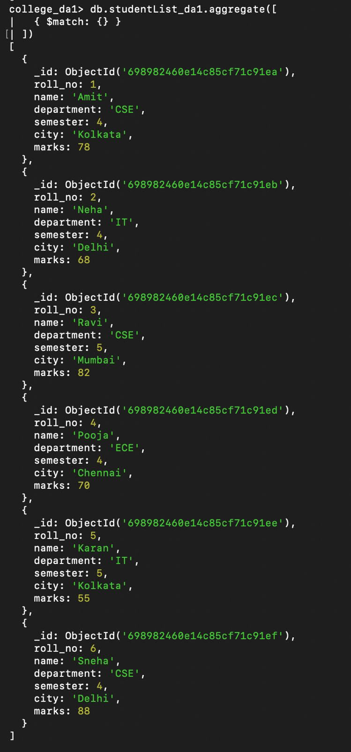

Q2. Display students belonging to CSE department.
Answer:
db.studentList_YourRollNo.aggregate([
{ $match: { department: "CSE" } }
])
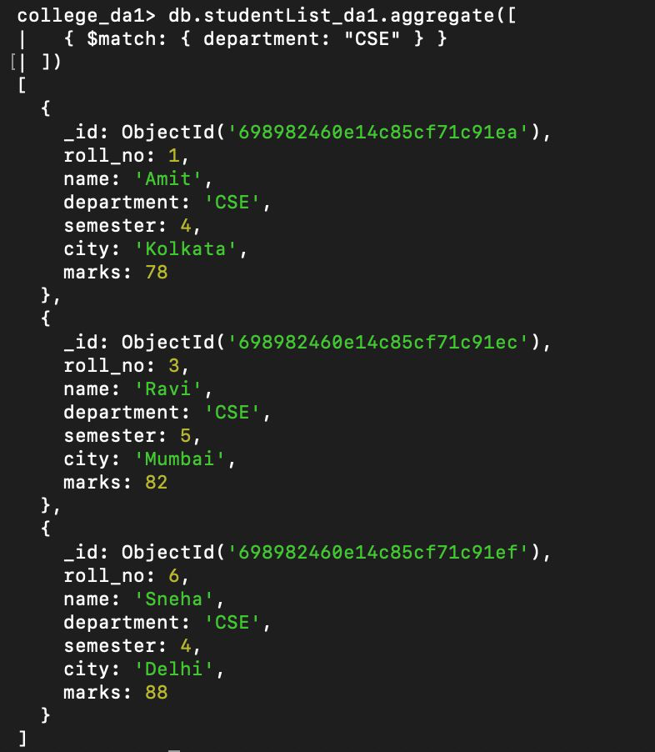

Q3. Display students of semester 4.
Answer:
db.studentList_YourRollNo.aggregate([
{ $match: { semester: 4 } }
])
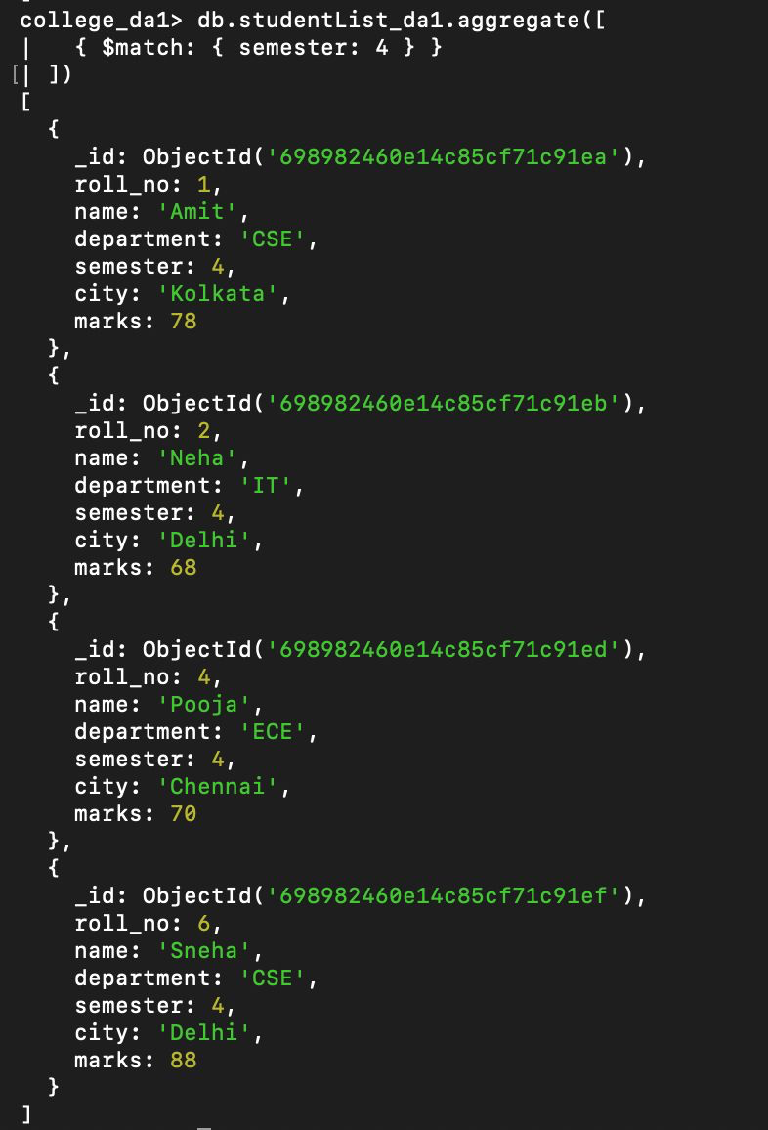

Q4. Display only name and marks of all students.
Answer:
db.studentList_YourRollNo.aggregate([
{
$project: {
_id: 0,
name: 1,
marks: 1
}
}
])
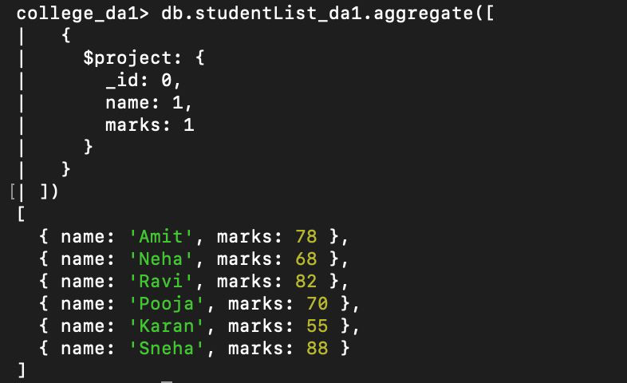

Q5. Find the average marks of all students.
Answer:
db.studentList_YourRollNo.aggregate([
{
$group: {
_id: null,
averageMarks: { $avg: "$marks" }
}
}
])
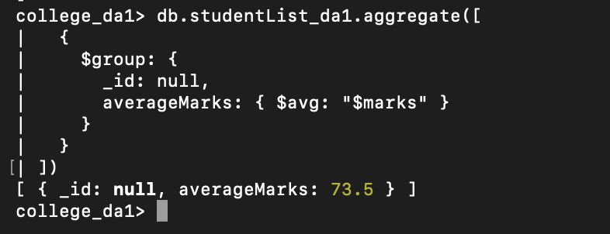

Q6. Find total marks scored department-wise.
Answer:
db.studentList_YourRollNo.aggregate([
{
$group: {
_id: "$department",
totalMarks: { $sum: "$marks" }
}
}
])
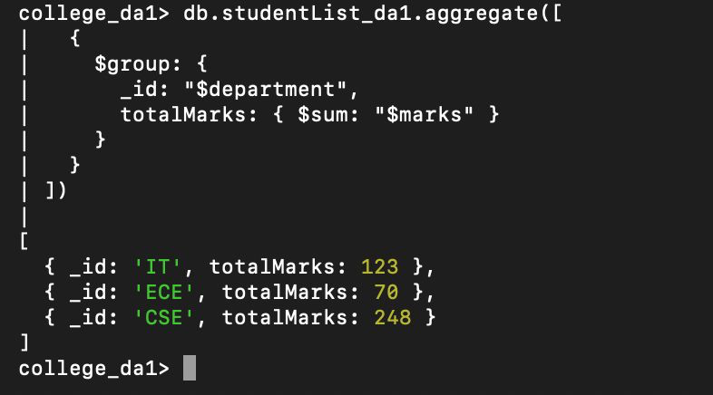

Q7. Find average marks department-wise.
Answer:
db.studentList_YourRollNo.aggregate([
{
$group: {
_id: "$department",
averageMarks: { $avg: "$marks" }
}
}
])
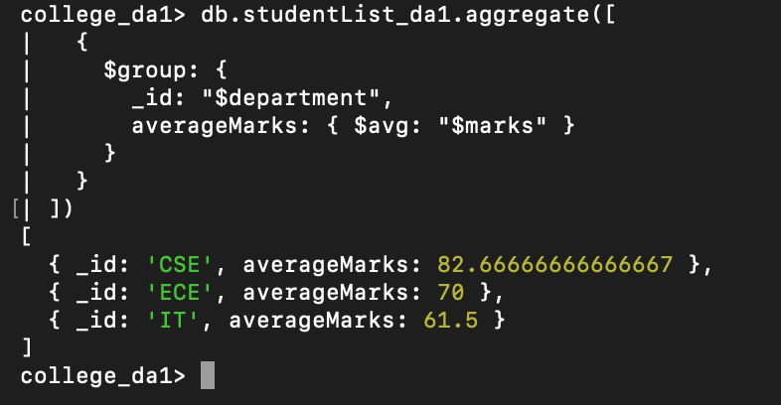

Q8. Find maximum marks scored in each department.
Answer:
db.studentList_YourRollNo.aggregate([
{
$group: {
_id: "$department",
maxMarks: { $max: "$marks" }
}
}
])
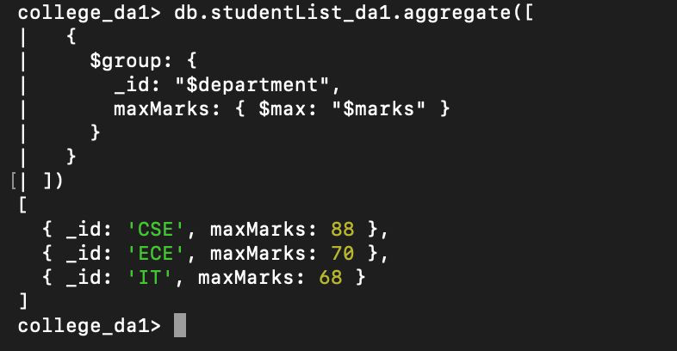

Q9. Count number of students in each department.
Answer:
db.studentList_YourRollNo.aggregate([
{
$group: {
_id: "$department",
studentCount: { $sum: 1 }
}
}
])
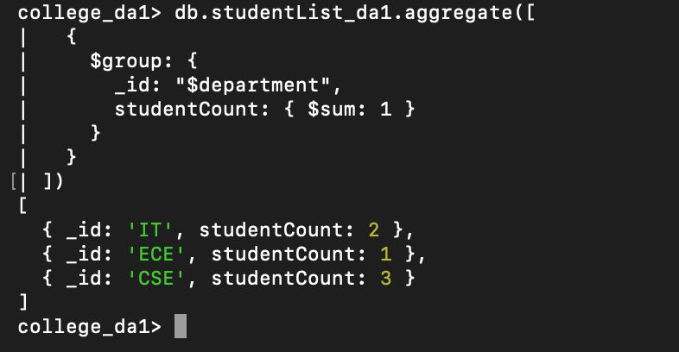

Q10. Display departments having average marks greater than 70.
Answer:
db.studentList_YourRollNo.aggregate([
{
$group: {
_id: "$department",
averageMarks: { $avg: "$marks" }
}
},
{
$match: { averageMarks: { $gt: 70 } }
}
])
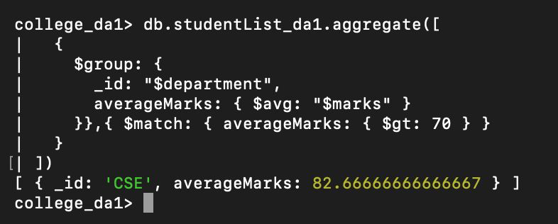

Q11. Sort students by marks in descending order.
Answer:
db.studentList_YourRollNo.aggregate([
{ $sort: { marks: -1 } }
])
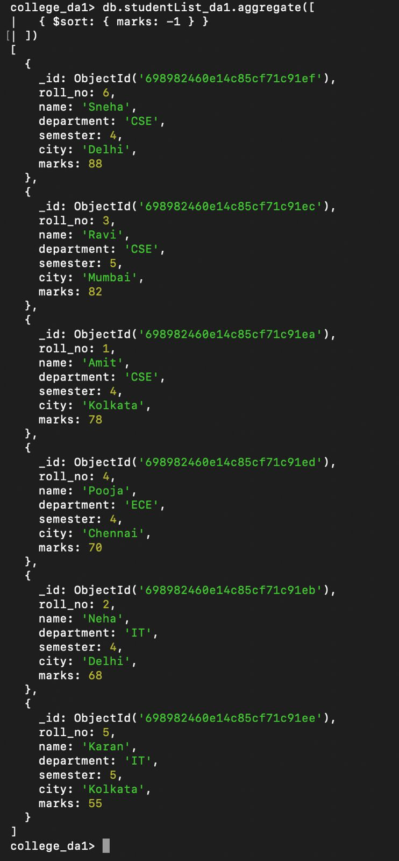

Q12. Display top 3 students based on marks.
Answer:
db.studentList_YourRollNo.aggregate([
{ $sort: { marks: -1 } },
{ $limit: 3 }
])
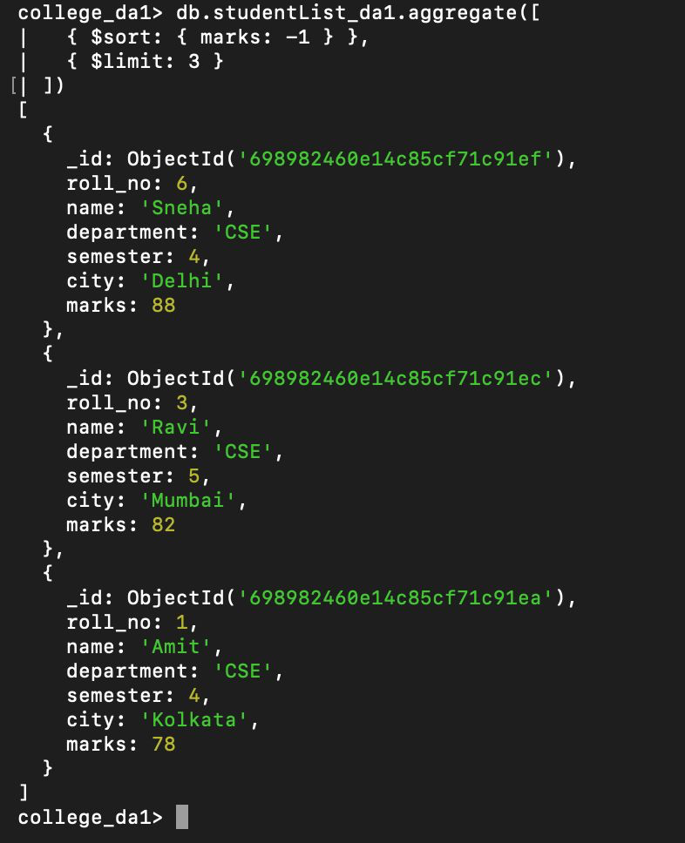

Q13. Display department-wise average marks sorted in descending order.
Answer:
db.studentList_YourRollNo.aggregate([
{
$group: {
_id: "$department",
averageMarks: { $avg: "$marks" }
}
},
{ $sort: { averageMarks: -1 } }
])
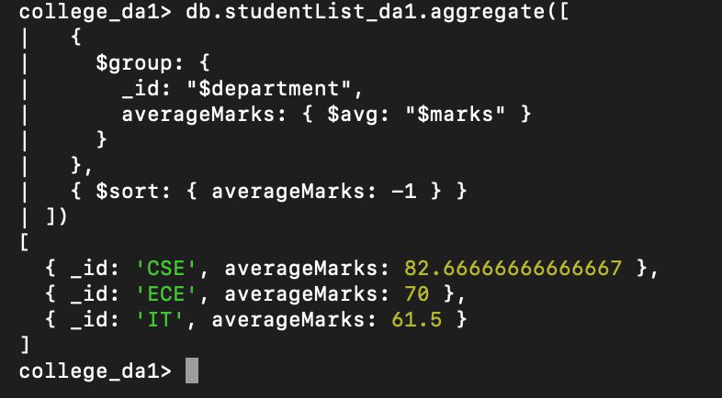

Q14. Display students belonging to Delhi or Kolkata.
Answer:
db.studentList_YourRollNo.aggregate([
{
$match: {
city: { $in: ["Delhi", "Kolkata"] }
}
}
])
